EEE 120
Lab 3 Answer Sheet (Online Class)
Registers, Counters and the “Brainless CPU”
Name:____Charlene Butler____________________________________________________
Semester/Year/Session (A/B):___Summer 2024 C_ Date:_06/16/2024______________
Task 3-1: Build and Test a 4-Bit D Register with Enable
Include a picture of your Digital circuit here:
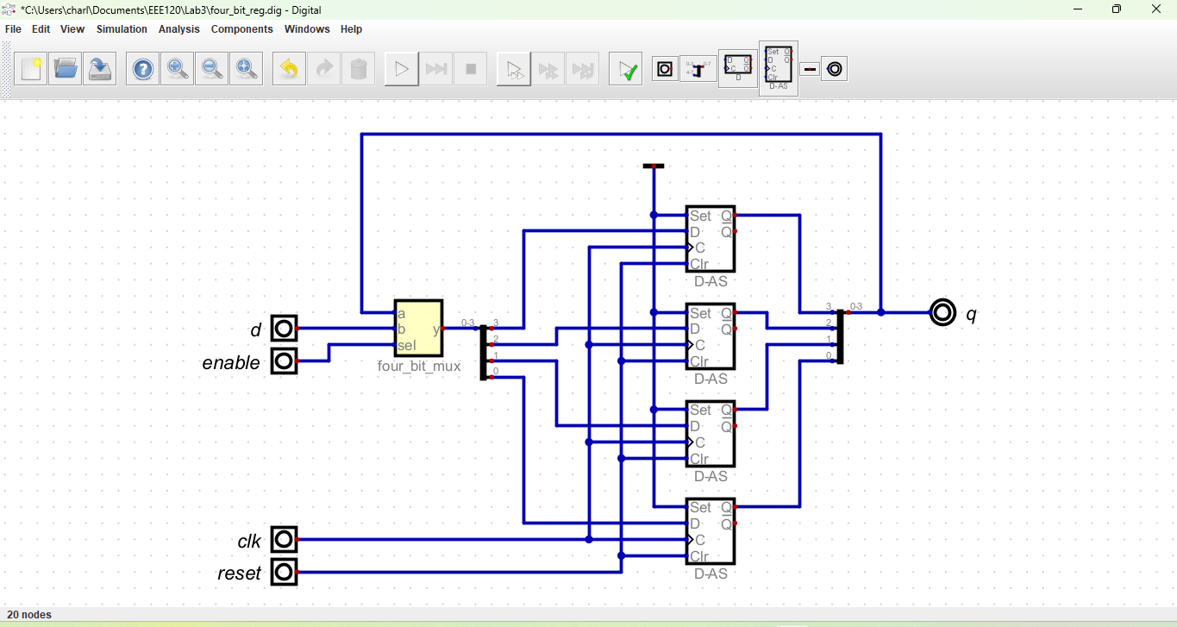
Please comment on the single biggest issue you were facing when designing the circuit.
My biggest issue was realizing how it all worked.
Include a picture of your GTKWave waveforms (timing diagram) here: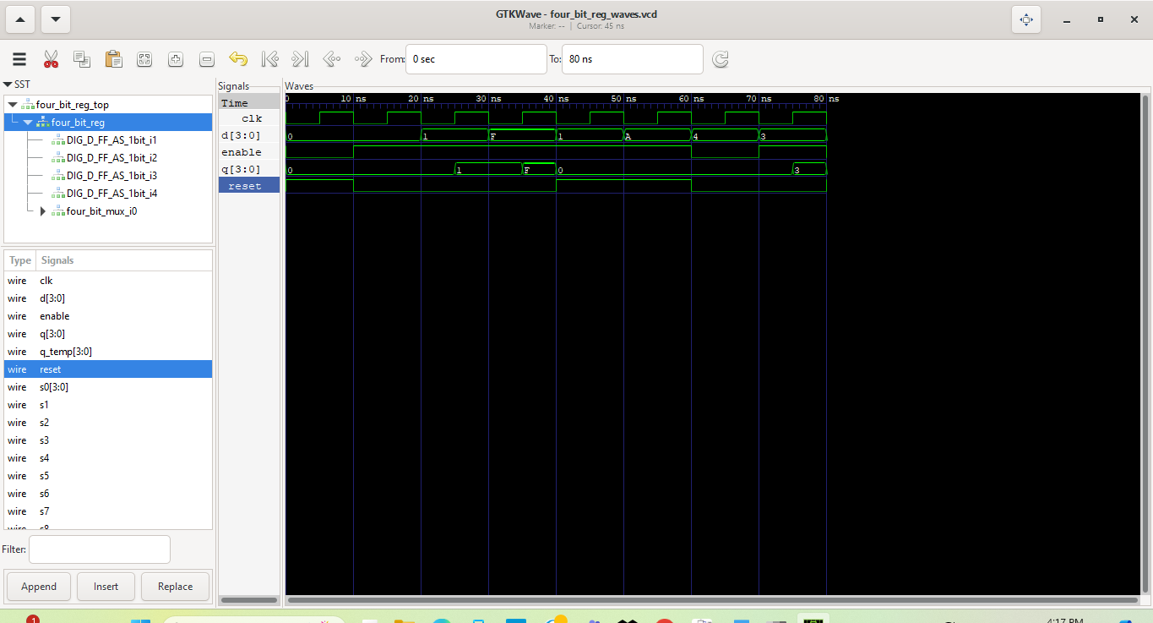
Did the circuit behave as expected? If no, what was wrong?
It behaved exactly like I expected it to.
Please comment on the single biggest issue you were facing when simulating the circuit.
No issues on this one at all.
Task 3-2: Build and Test a 4-Bit UP Counter
Include a picture of your Digital circuit here:
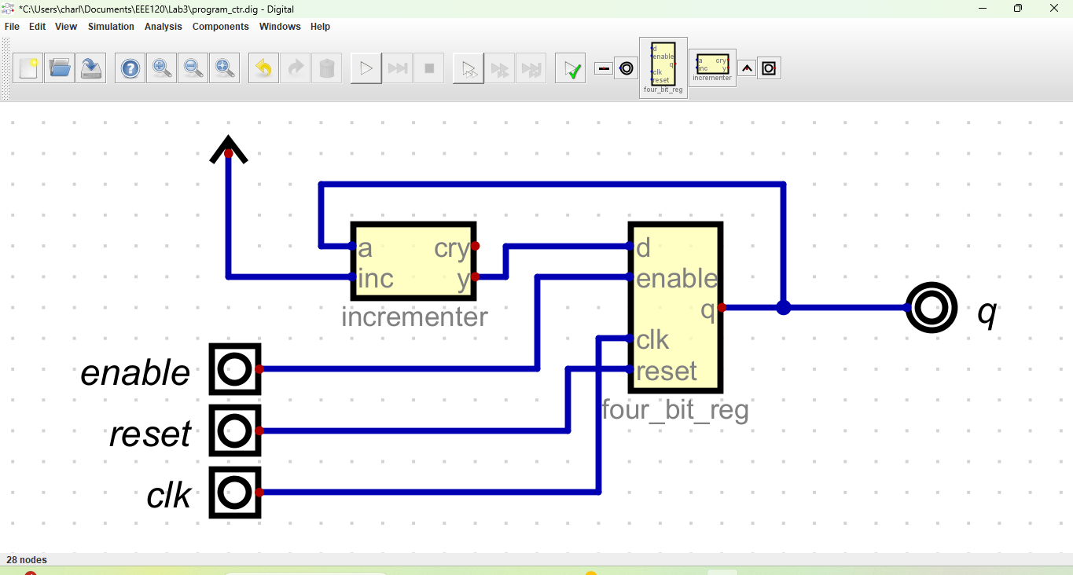
Please comment on the single biggest issue you were facing when designing the circuit.
No issue with this one.
Did the circuit behave as expected? If no, what was wrong?
It behaved exactly as expected.
Please comment on the single biggest issue you were facing when simulating the circuit.
No issue.
Task 3-3: Create a 4-Bit RAM with 16 4-Bit Words
Include a picture of your Digital circuit here:
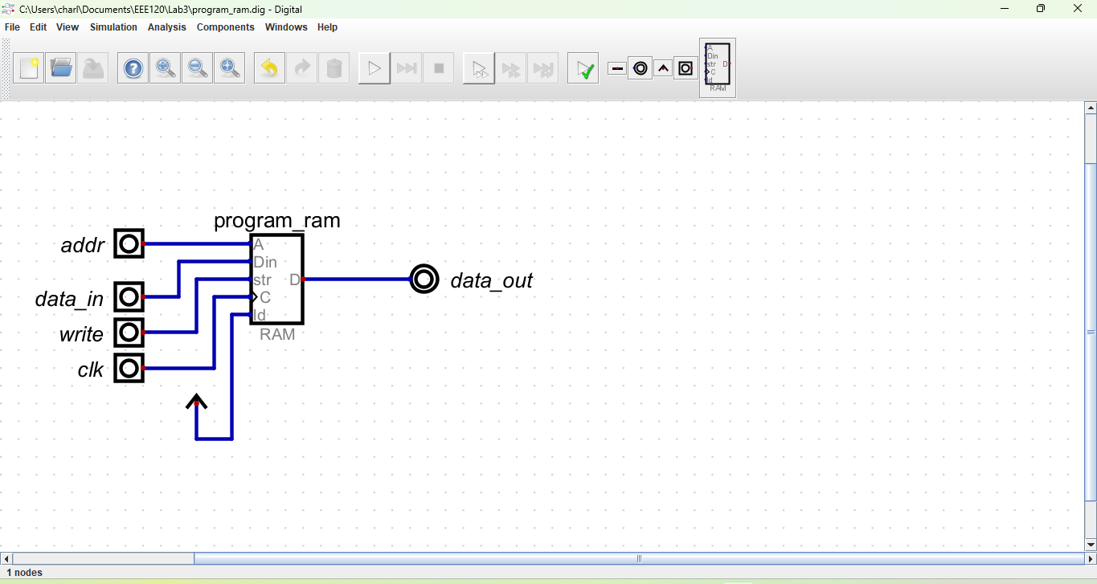
Please comment on the single biggest issue you were facing when designing the circuit.
No issues.
Did the circuit behave as expected? If no, what was wrong?
Exactly as expected.
Please comment on the single biggest issue you were facing when simulating the circuit.
No issues.
Task 3-4: Build and Test the Brainless Central Processing Unit
Include a picture of your Digital circuit here:
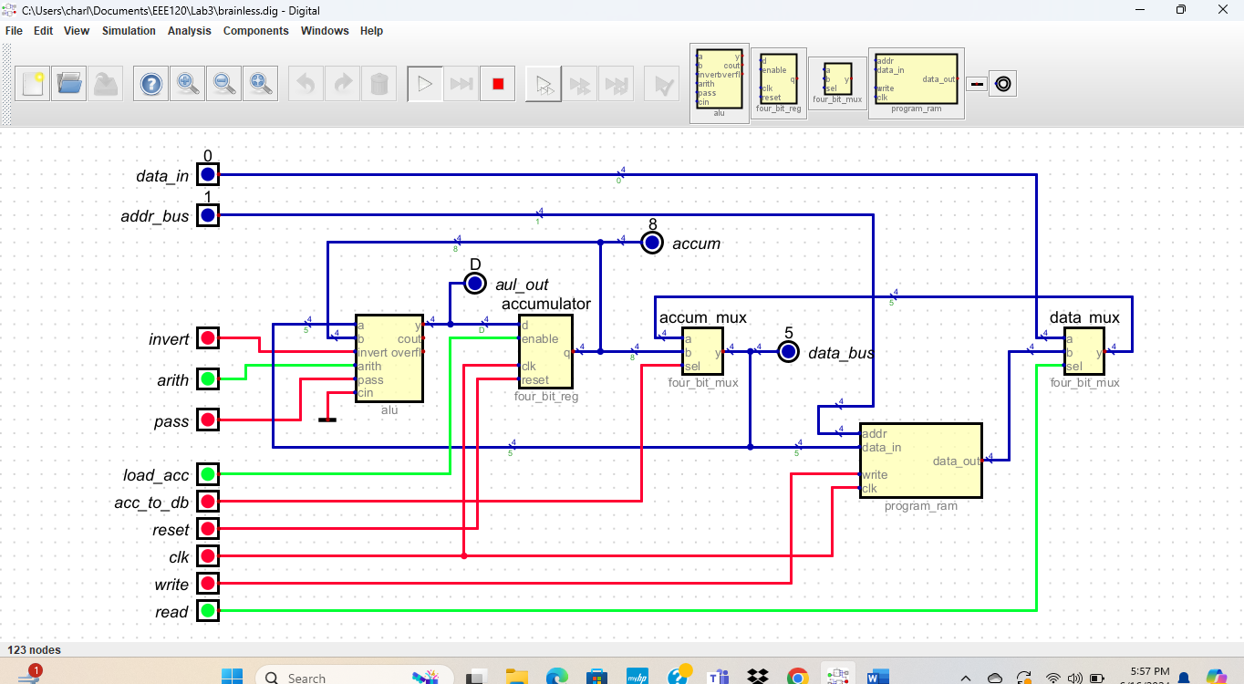
Please comment on the single biggest issue you were facing when designing the circuit.
No issues.
Did the circuit behave as expected? If no, what was wrong?
Yes, it behaved as expected.
Please comment on the single biggest issue you were facing when simulating the circuit.
No issues.
Task 3-5: Simulate the Brainless Central Processing Unit
Include a picture of your GTKWave waveforms (timing diagram) here:
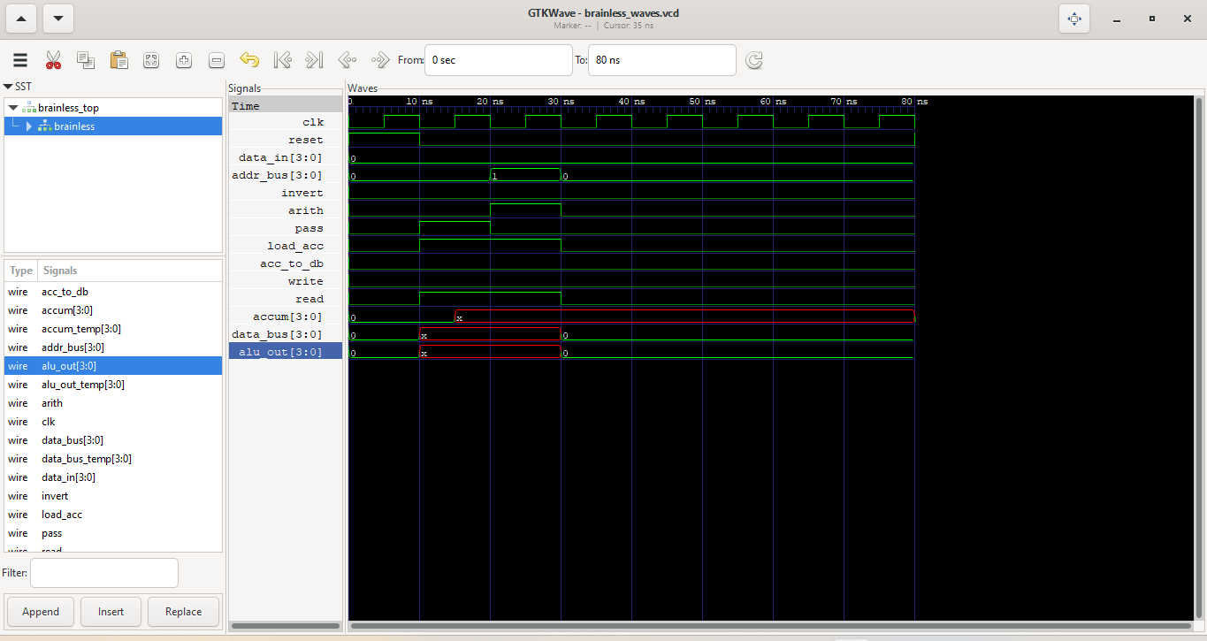
Did the circuit behave as expected? If no, what was wrong?
Yes, the digital circuit works just fine, but I can not figure out what happened with my waves. They should have 3, 5, and 8 and NOT x.
Please comment on the single biggest issue you were facing when simulating the circuit.
See the answer above.
Task 3-6: Create Additional Tests
In order to stay organized, you may use the table here to map out the different values for each test. Repeat this table for each of the additional ALU operations.
Table 1
Operation [ Add operand to Accumulator (ACC) ]
Control Line | Value
data_in | 0
addr_bus | Address of operand
write | 0
read | 1
acc_to_db | 0
load_acc | 1
pass | 0
invert | 0
arith | 1

Include a picture of your Digital circuit here:
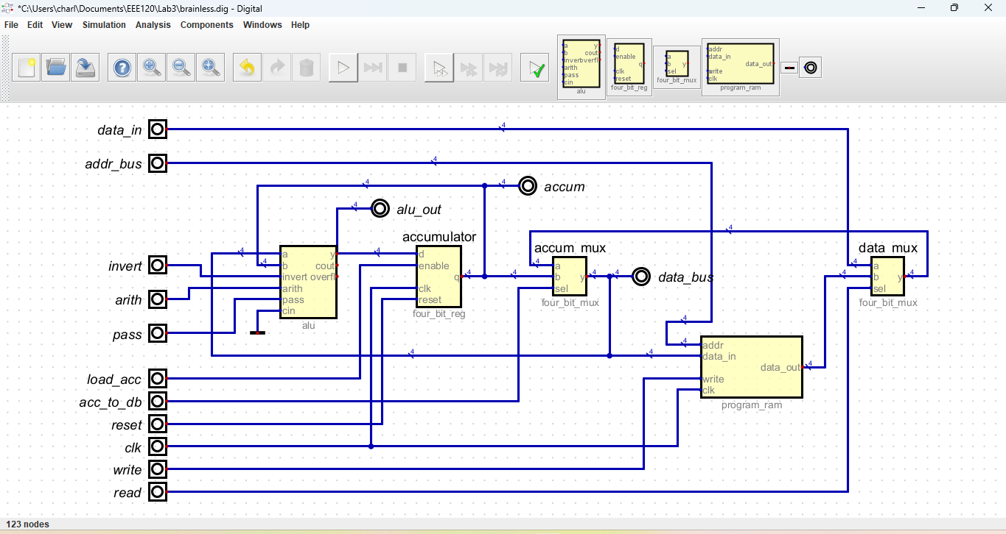
Include a picture of your GTKWave waveforms here (one per required test):
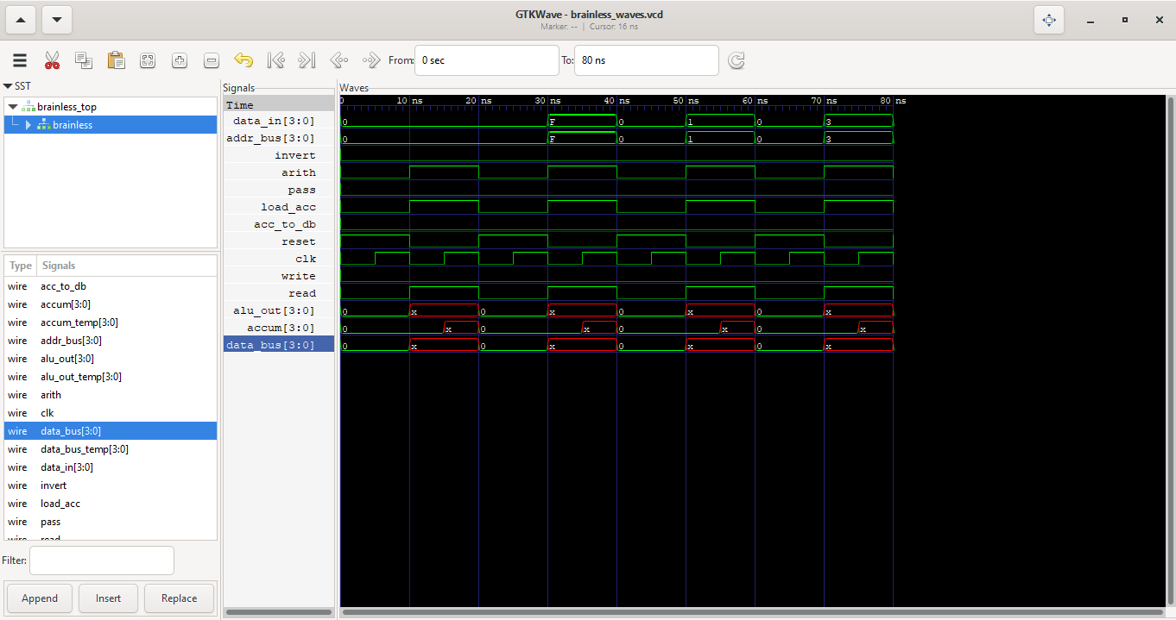
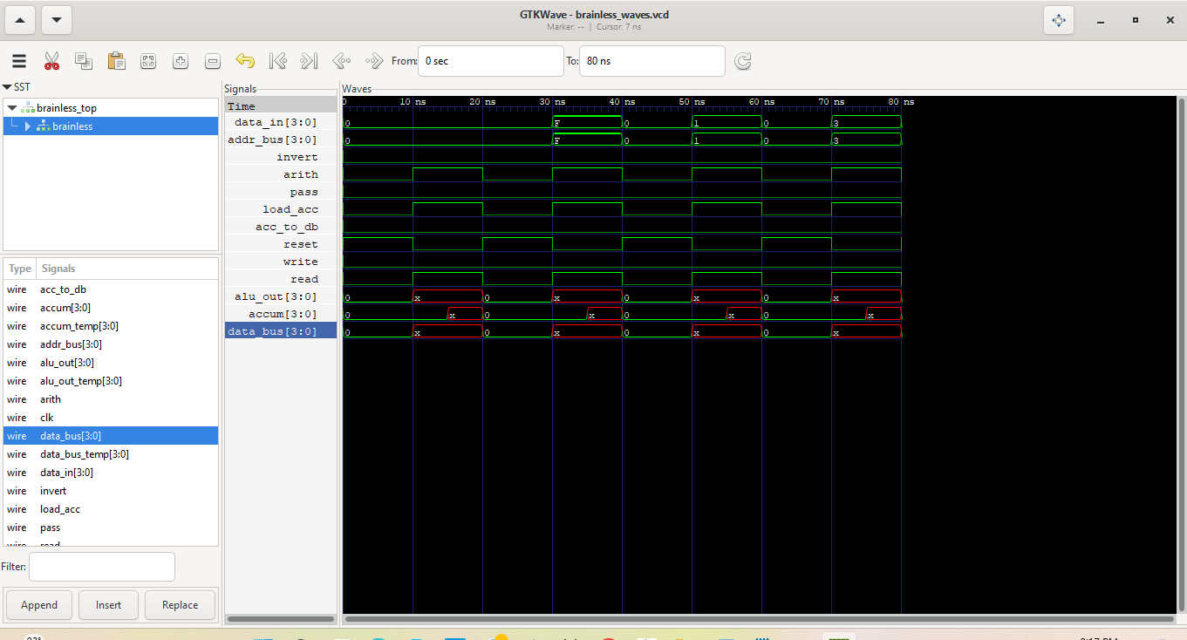
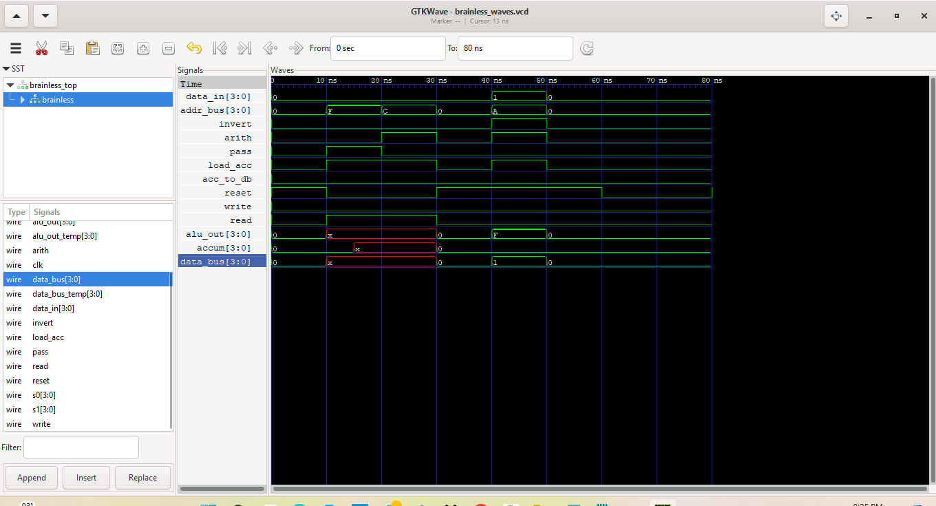
Please comment on the single biggest issue you were facing when designing the circuit.
No issues.
Did the circuit behave as expected? If no, what was wrong?
No, it is showing x’s in the waveform. I have tried everything to get this to work properly.
Please comment on the single biggest issue you were facing when simulating the circuit.
The waveform.
Task 3-7: Create a video and submit your report (Optional)
[This task is useful to get partial credit if your schematic is not working. Take advantage of it to explain to the grader your understanding of the circuit. More importantly, explain where you think the mistake is in and what you would do if you were given more time to fix it.]
Record a short video showing your schematic in Digital and your waveforms in GTKWave. Be sure to show yourself in the video and show your screen. Upload the video to your Google Drive (personal one or ASU one). Copy and paste the sharing link to that video here. Make sure the link is working and pointing to the correct video. Do NOT upload your video to YouTube. If your circuit is not working as expected, explain in the video how it is not working and where you expect the mistake to be from.
Video Link:
At the beginning of your recording, say your name, the task number and circuit name. Be brief in your recording. Submit the completed template to Canvas.
Make sure all your files are in the Lab3 directory. Create a zip file of the Lab3 directory. Remember to turn in the zip file and your completed template on Canvas! Make sure you upload the template before the zip file.

Lab 3: Lab Report Grade Sheet

Name:

Instructor Assessment
Grading Criteria | Max Points | Points Lost
Description of Assigned Tasks, Work Performed & Outcomes Met
Task 3-1: Build and Test a 4-Bit D Register with Enable | 10
Task 3-2: Build and Test a 4-Bit UP Counter | 10
Task 3-3: Create a 4-Bit RAM with 16 4-Bit Words | 10
Task 3-4: Build and Test the Brainless Central Processing Unit | 10
Task 3-5: Simulate the Brainless Central Processing Unit | 10
Task 3-6: Create Additional Tests | 30
Task 3-7: Create a video and submit your report (Optional)
 | Points Lost
Lab Score (80 points total) | Late Lab
 | Lab Score

